**DSP project**

Mariam Mokhtar 202000396

Mahmoud Thabet 202000328

Nasrah Mohamed 202000925

Omar Morgan 202001207

Block diagram:

**Filter design problem:**

We are trying to design a filter to separate the signals from each other as in a real world scenario there are multiple IOT devices connected at the same time so we are trying to separate them into separate signals once again at the receiver so that the receiver can determine what action to do next with information give to it by the IOT device.

According to the standard 180 KHz is the signal bandwidth and the next signal starts at 200 KHz and so on

Thus we need to make the passband at 180 KHz and the stopband 200 KHz we have the transition region at 10kHz since we divide by 2.

The ripples preferably not exceed 3db and by maximum 6db, Moreover the coefficient must not go beyond 256 coefficient as according to our system it has a maximum of 256 memory elements, stopband attenuation should be -23db as this the max value that could be sent through the whole signal so anything more will only remove the noise but not the neighboring signal thus for our problem we could set this to be the desired stopband if it is more than this it is also fine,

Evaluation of filters:

**Equiripple 256 coefficients**

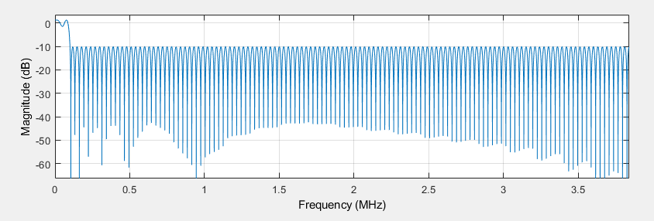

This design didn’t make the cut (pun intended) because the attenuation was lower than what we wanted

**Hamming 256**

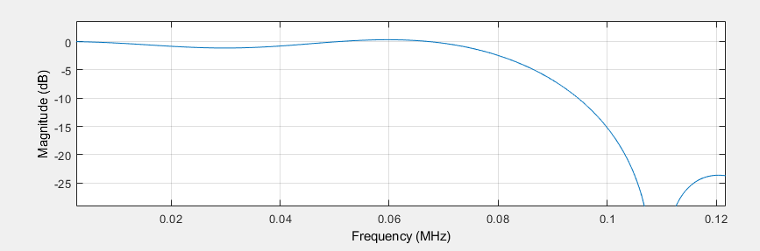

This design meets most of the specifications so we could use it but some filter out there exists that is better than this

**Taylor 256:**

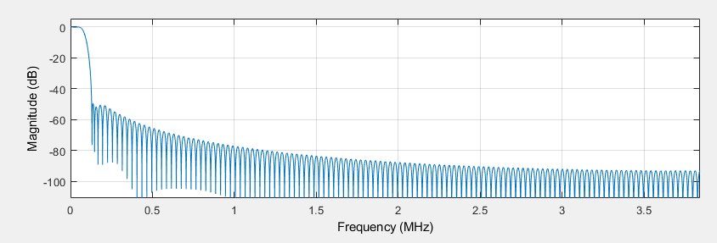

Zoomed:

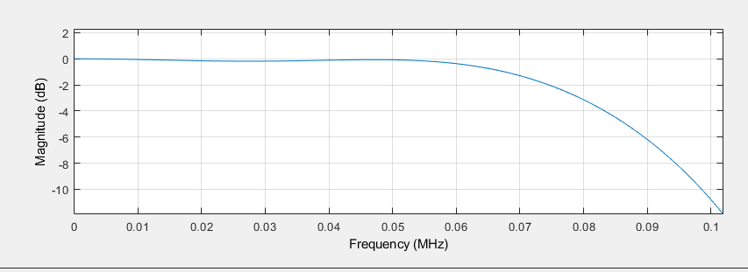

This filter meets all of the specification and is below the number of coefficients that we set as a constraint for our problem

Stopband attenuation: -50db

Passband ripples: 6 db

Transition region: is 10000 Khz

**Hamming 250:**

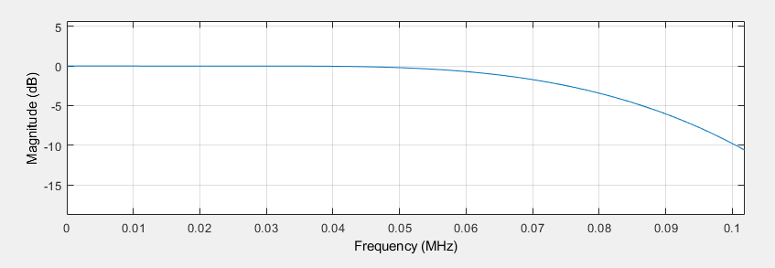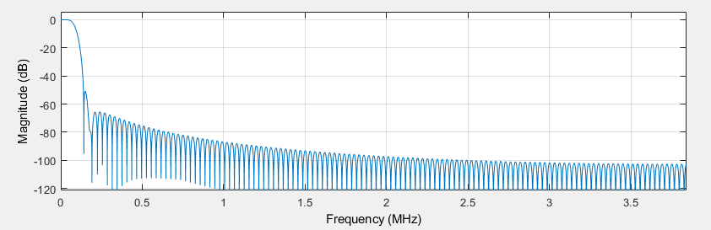

This filter is very great the passband ripples were 6db, stopband attenuation: -50db transition region 10kHz

**Least Square 256:**

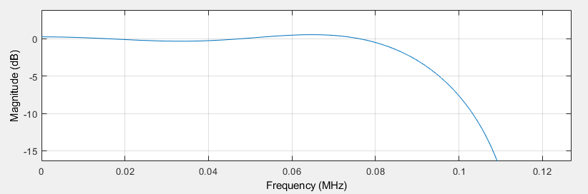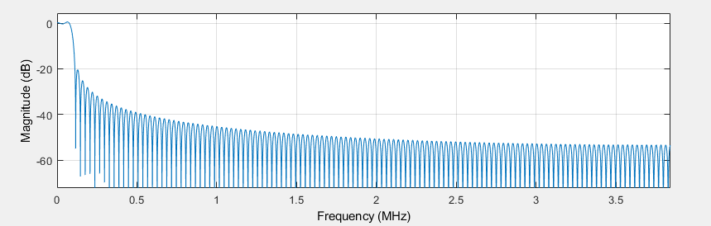

This filter wasn’t bad but other methods obtained above had better filters thus this one was not used as it has more ripples and the attenuation is lower

**Kaiser 256**:

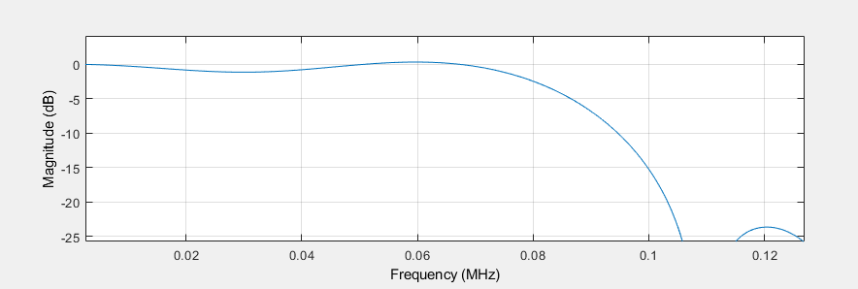

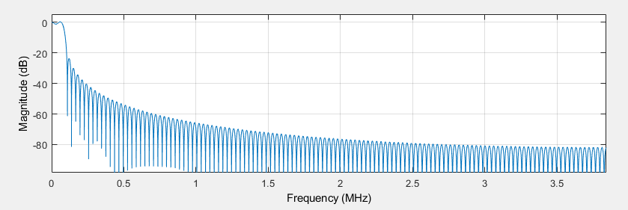

This one has larger ripples and the attenuation is not better thus it was also not used.

Applications and helath concerns of iot devices:

Narrowband Internet of Things (NB-IoT) applications have the potential to significantly impact various aspects of public health, safety, and the broader socio-economic and environmental landscape. One prominent NB-IoT application that exemplifies these impacts is the deployment of smart city solutions, with a focus on smart healthcare and environmental monitoring.

1. Public health

* **Reporting and monitoring:** IoT enables real-time monitoring of patients that can help save a life in the event of a medical emergency. New Zealand has one of the highest mortality rates of “Sudden Infant Death Syndrome” and this is being tackled by IoT. Sensors that monitor medical parameters such as breathing rate, sleep position, and heart rate are being used to monitor the well-being of a child 24/7. These sensors are designed to notify healthcare providers and parents about severe health conditions. Similarly, IoT is helping with the easy monitoring of elderly people through smart devices. Clinicians are now able to track vital signs and even fall detection in real time!
* **Automating patient care:** now tracking and real-time alerting is made possible with the use of IOT innovations one of which is smart pill bottles which help in tracking whether a patient is adhering to his dosage of prescriptions or not and evaluate the suggested course. This also helps patients who forget to take their medicine on time!

1. Safety

* **Potential risk monitoring:** Nowadays, forward-thinking organizations implement IoT technology to monitor workplace equipment through predictive maintenance. That allows noticing different structural failures in the connected devices before an accident occurs. Predictive maintenance also enables companies to take proactive actions depending on data patterns. Thanks to combining IoT and machine learning (ML) algorithms, companies can predict possible issues before they affect workers.
* **Traffic Management**: Smart traffic management systems utilizing NB-IoT can enhance road safety. Connected vehicles and infrastructure can share real-time data on traffic conditions, allowing for dynamic traffic management and reducing the risk of accidents

1. Environment

* **Saving Energy:** Energy comes from power plants that are very carbon-intensive, and therefore, if we reduce our energy demand from the power plant, we will reduce carbon dioxide emissions and our carbon footprint.

IoT can be greatly beneficial for automatically turning devices on or off depending on the situation. For example, an IoT device that can sense temperature can automatically turn on the AC when the outside temperature goes above a certain mark, and it could also automatically turn the AC off when it is cooler outside too. It could also be a device that is set to turn down the heating when you go to bed, while raising the temperature again at a certain time in the morning. An IoT device that detects movement can know when someone is in a specific room and turn on the light automatically and also turn the lights off when no one is in the room.

* **Waste Management:** NB-IoT applications can optimize waste management by tracking waste levels in bins and coordinating efficient collection routes. This not only reduces operational costs but also minimizes the environmental impact of inefficient waste disposal.
* **Wildlife Conservation:** IoT has also been used to gather data and track endangered animals. The information automatically gathered by IoT devices has helped scientists understand animal’s behaviors, health, and habitat in a non-intrusive way.

1. Society

IoT has influenced and continues to shape our society

* **Connectivity:** IoT has transformed homes into smart environments by enabling the interconnectivity of devices. Smart thermostats, lights, security systems, and appliances contribute to energy efficiency, convenience, and improved security.
* **Security and Privacy Challenges:** The proliferation of connected devices also brings challenges related to security and privacy. As more devices collect and share data, there is an increased risk of cyber-attacks and unauthorized access. Ensuring the security of IoT networks and data becomes crucial.
* **Bandwidth and network traffic challenges:** Organizations should be able to develop massive, scalable and valuable IoT capabilities known as massive machine-type communications (mMTC) or massive IoT (MIoT), in short. MIoT deployments could generate and harness huge amounts of data to drive advanced analytical and artificial intelligence (AI) programs and provide mission-critical services.

1. Economy

* **Increased competitiveness:** IoT can help businesses become more competitive by improving their products and services, reducing costs, and providing better customer experiences. This can help businesses gain a competitive advantage in the global marketplace, which can benefit the country's economy.
* **Better decision-making:** IoT can provide real-time data and insights that can help policymakers and businesses make better decisions. This can lead to more informed and effective policies and strategies that can improve the country's economy.
* **Industrial growth:** Machine to machine communication opens up a world of potential growth in the manufacturing industry.

References

* Srivastava, S. (2023, December 20). How IOT in healthcare is revolutionizing the medical industry. Appinventiv. <https://appinventiv.com/blog/iot-in-healthcare/>
* Andrii Rybakov. (2021, June 3). *How to improve workplace safety with IOT*. AgileVision.io - Custom Software Development Company. <https://www.agilevision.io/blog/how-to-improve-workplace-safety-with-iot>
* Chen, S., Xiong, G., Xu, J., Han, S., Wang, F.-Y., & Wang, K. (2018). The Smart Street Lighting System based on Nb-IOT. *2018 Chinese Automation Congress (CAC)*. <https://doi.org/10.1109/cac.2018.8623281>
* Hübschmann, I. (2022, March 30). How IOT can help the environment. Nabto. <https://www.nabto.com/how-iot-helps-the-environment/>
* Zubovich, N. (2024, January 4). *Impact of internet of things(iot) on Business & Economy [2024 trends]*. SumatoSoft. <https://sumatosoft.com/blog/impact-of-internet-of-things-iot-on-the-business-economy-2022-trends>
* Satyabrata. (2023, May 16). *Environmental and economic impact of IOT*. Tutorialspoint. <https://www.tutorialspoint.com/environmental-and-economic-impact-of-iot>
* Inc, N., & Munawar, S. (2021, March 22). *7 most important daily life applications of IOT*. Novateus. <https://novateus.com/blog/daily-life-applications-of-iot/>
* Societal benefits of the IOT. (n.d.). <https://www.arduino.cc/education/societal-benefits-of-the-iot>
* Schlienz, J., & Raddino, D. (2016). Narrowband internet of things whitepaper. White Paper, Rohde&Schwarz, 1-42.
* Daume, I., Hal, M., & Daniel. (2002). *A Noisy-Channel Model for Document Compression*. https://doi.org/10.21236/ada459360
* Chen, M., Miao, Y., Hao, Y., & Hwang, K. (2017). Narrow band internet of things. IEEE Access, 5, 20557–20577. https://doi.org/10.1109/access.2017.2751586